A Project submitted

To

CHATTISGARH SWAMI VIVEKANAND TECHNICAL UNIVERSITY
Bhilai (C.G) , India
for
the Award of Degree
of

Bachelor of Engineering

in
Information Technology

By
Miss Gargi Mishra
Enrollment No. :

Miss Pallavi Upadhyay
Enrollment No.: AA9884

Under the Guidance of
Lect. (Mr.)Toshant kumar
Lecturer

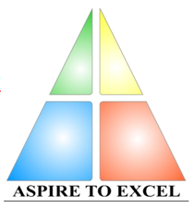
Department of INFORMATION TECHNOLOGY
Bhilai Institute Of Technology

Bhilai House, Durg -491001, CHHATTISGARH , INDIA
(An ISO 9002 Certified Institute)

session : 2009 – 2010

DECLARATION

I the undersigned solemnly declare that the report of the project work entitled Civic Registration System , is based on my own work carried out during the course of my study under the supervision of Mr Toshant kumar .

I assert that the statements made and conclusions drawn are an outcome of the project work . I further declare that to the best of my knowledge and belief that the report does not contain any work which has been submitted for the award of any other degree/diploma/certificate in this university /deemed university
of India or any other country.

(Signature of the candidate) (Signature of the Candidate)

Name of the candidate: Gargi mishra Name of the candidate: Pallavi Upadhyay
Roll No. : 3013306013 Roll No. : 3013306028 Enrollment No. : AA9831 Enrollment No. : AA9884

Signature of Supervisor
Lect. (Mr.) Toshant Kumar
Lecturer
Information Technology
BIT, Durg, (C.G)

CERTIFICATE BY THE SUPERVISOR

This is to certify that the report of the project Civic Registration System is a record of research work carried out by Gargi Mishra bearing Roll No: 3013306013 & Enrollment No. AA9831 and Pallavi Upadhyay bearing Roll No. 3013306028 & Enrollment No. AA9884 under my guidance and supervision for the award of Degree of Bachelor Of Engineering in Information Technology,Chhattisgarh Swami Vivekanand Technical University , Bhilai (C.G) , India .
To the best of my knowledge and belief the project
- Embodies the work of the candidate him/herself ,
- Has duly been completed,
- Fulfils the requirement of the Ordinance relating to the B.E. degree
of the University and
- Is up to the desired standard both in respect of contents and language for being referred to the examiners .

( Signature of HOD with seal ) (Signature of the Supervisor)

Name :Lect.(Mr.)Toshant Kumar
Designation : Lecturer
Department : Information Technology
Name and Address of the Institute : BIT, Durg, (C.G)

Forwarded to Chhattisgarh Swami Vivekanand Technical University
Bhilai

( Signature of Director/Principal )
Bhilai Institute Of Technology
Bhilai House Durg-491001 ,

CHHATTISGARH , INDIA

CERTIFICATE BY THE EXAMINERS

The project entitled Civic Registration System submitted by Gargi Mishra (Roll No. 3013306013 Enrollment No. AA9831) and Pallavi Upadhyay (Roll No. 3013306028 Enrollment No. AA9884) have been examined by the undersigned as a part of the examination and is here by recommended for the award of the degree of Bachelor of Engineering in Information Technology of Chhattisgarh Swami Vivekanand University , Bhilai (C.G) .

Internal Examination External Examination
Date : Date :

ACKNOWLEDGEMENT

We wish to acknowledge with a deep sense of hearty gratitude and indebtedness to Prof.(Dr.) M.K Kowar Principal , BIT Durg , Mrs Alpna Rawal , Head of Department I.T. , who gave us this opportunity to experience project work & his valuable suggestion during this project have been invaluable.

We take this opportunity to voice & record our sincerest gratefulness towards our esteem Supervisor Lect. (Mr.) Toshant Kumar under whose able guidance the project work has been brought to completion.

Our heart leaps up in thankfulness for his benevolence & time to time help, valuable suggestions, constructive criticism & active interest in the successful completion of this project work.

We are also thankful to all our honorable teachers of the Information Technology Department and our parents whose valuable support helped us and kept us motivated all through.

(Signature of Student ) (Signature of Student)

Name: Gargi Mishra Name : Pallavi Upadhyay
BIT,Durg(C.G.) BIT, Durg, (C.G)

INDEX

Page No.
1. Introduction 7
2. Planning 8
2.1) Project Description 8
2.2 ) Problem Statement 9
2.3 ) Solution Strategy 9
2.4 ) Life Cycle Model 10
2.5 ) Team Structure 11
2.6) Software Metrics 12
2.6.1.Complexity Category 12
2.6.2 LOC 12
2.6.3 Effort 12
2.6.4.Duration 12
2.6.5 Staffing 12
2.6.6 Cost 12
2.7) Requirement Specification 13
3. Analysis Phase 14
3.1 DFD 16
4. Design Phase 17
4.1 Interface Design 17
5. Implementation Phase 27
5.1 Coding Standards 28
5.2 Coding 29
6. Testing 45
7. Limitations and Future Enhancements 49
8. Bibliography 50

INTRODUCTION

The project aims at creating proper data records of birth , marriage ,death and fetus of the area . the records are managed easily using different modules of this project . We have many four forms which collects the records of the individuals . It provides us with different information . It is user-friendly software which is quick to learn and which ensures reliability.

Our project provides facilities for the user to enter information as well as display it efficiently. It also provides facility for enquiry about the individuals in various areas. It helps in taking survey and presenting the figures thus helping the government officials to get,manage and classify the data easily and quickly .
This application will take as input all data from the user and will display it or give output when requested by the user.

PLANNING

Project Description

The working of the CIVIC REGISTRATION SYTEM is described as follows:

It consists of the main form from which all the other modules are linked . The four different modules are as follows:

BIRTH FORM : It consists of many fields like date of birth ,father’s name, mother’s name,
Area ,hospital ,etc. As the data is feeded the whole information is stored in the computer and a certificate is generated. The information can be accessed anytime.

MARRIAGE FORM : It consists of many fields of both the husband and wife. The fields are
Date of marriage,etc. As the data is feeded the whole information is stored in the computer and a certificate is generated immediately. The information can be accessed anytime.

DEATH FORM : It consists of many fields like name of person ,father’s name, mother’s name,
etc. it also includes the factor whether the death is accidental ,murder ,etc. As the data is feeded the whole information is stored in the computer and a certificate is generated. The information can be accessed anytime.

FETUS FORM : It consists of many fields like date of birth ,father’s name, mother’s name,
Area ,hospital ,etc. As the data is feeded the whole information is stored in the computer and a certificate is generated. The information can be accessed anytime. It mainly helps in producing figures which is useful for issuing graphs and calculating the fetus rate.

PROBLEM STATEMENT

The manual-handling of death , birth , marriage and fetus records which where earlier handled manually. It is cumbersome to refer to files every time some information regarding an individual. Moreover, the addition of new records makes the job all the more tedious.

Issuing proper figures to and by the government becomes easier.

SOLUTION STRATEGY

We can provide software-assistance in providing certificates to individuals and handling proper information . By providing external interfaces and making connectivity with the database, the records can be maintained in a systematic way such that the required information can be easily accessed and retrieved and new records can be added with equal ease.

LIFE CYCLE MODEL USED

We have employed the Waterfall Model for the software development.
1) It is a simple model in which the phases are organized in linear order.
2) The various phases in this model are-
a)Feasibility Study-The main aim of this study activity is to determine whether it would be financially or technically feasible to develop the project. It involves the analysis of the problem and collection of all relevant information relating to the product such as different data items which would be input to the system, the processing required to be carried out on these data, the output data required to be produced by the system as well as constraints on the behavior of the system.
b)Requirement Analysis-The aim of the requirement analysis is to provide individuals with the certificate that is for civic registration . It is begun by collecting all relevant data regarding the individual and storing the information. During this activity, the user requirements are systematically organized into an SRS document. The important components of this document are the functional requirements, the non-functional requirements and the goals of implementation.
c)Design-This phase is concerned with identifying software components like functions, data streams ,data stores and specifying software structure. There are two categories of design-
1. Architectural Design-It involves identifying the software components, decomposing the software components into modules and specifying the interconnection between the various components.
2. Detailed Design-It is concerned with details of the implementation procedures to process the algorithms, data structures and interaction between the modules and data structures.
d)Implementation-It involves the translation of the design specifications into source code. It also involves activities like debugging, documentation and unit testing of the source code. In this stage various styles of programming can be followed like built-in and user-defined data types ,secured type-checking, flexible scope rules, exception handling, concurrency control etc.
e)Testing-It involves two kind of activities-
1. Integration Testing-It involves testing of integrating various modules and testing their overall performance due to their integration.
2. Acceptance Testing- It involves planning and execution of various types of tests in order to demonstrate that the implemented software system satisfies the requirements stated in the requirements document.
TEAM STRUCTURE
The (R & R) project is employing the Democratic Decentralized Team Structure with Gargi, and Pallavi as team members. Individuals were responsible for coordinating team-activities and taking final decisions. All the decisions were taken by the collective effort of the members. All the activities carried out during the project were collectively discussed and handled.

Communication Path in Democratic Team Structure
Team Member 1 : Pallavi Upadhyay
  - Identified the project requirements and main features to be proposed in the application.
  - Analysis of the problem and collection of all relevant information relating to the project was done.
  - Decision on different data items, which would be input to the system, the processing required to be carried out on these data and the output data required to be produced by the system, was taken.
  - The various constraints on the behavior of the system were also identified.
5. Analysis of the proposed system was done from the available information.
6. User requirements were systematically organized into SRS. It contained functional
requirements, non-fu8nctional requirements and goals of implementation.
7. Data modeling activity was carried out which included Data Dictionary (DD), ERD,
DFD.
Team Member 2 : Gargi Mishra
- The software components were identified like functions and data structures.
- Interconnection between various components was done.
- Activities like design of data representation, decision on type of algorithms was taken.
- Translated design specifications into source code.
5. Testing of integrating various modules of the project was done.
6. The overall performance of the software was accessed.
7. Ensured that the implemented software system satisfied the requirements stated.

SOFTWARE METRICS
Complexity Category-The (R& R) project belongs to the category of trivial project as its LOC is calculated to be 622 lines of code. It thus comes under Organic Basic COCOMO Model as cost drivers are not given..
Loc of (R&R) project is 622 Lines Of Code
We have the following equations :-
E = a*(KLOC)^{b}
D = c*(E)^{d}
N = E/D
P = KLOC/E
Where:
E-> effort applied by per person per month
KLOC-> estimated thousands of lines of code delivered for the project, and the coefficients a, b and c, d are taken from the table below.
N-> staffing
P-> productivity
The table for Basic COCOMO Model is as follows-
Software Project | a | b | c | d
Organic | 2.4 | 1.05 | 2.5 | 0.38
Semidetached | 3.0 | 1.12 | 2.5 | 0.35
Embedded | 3.6 | 1.20 | 2.5 | 0.32
E = 2.4*(0.622)^{1.05}
=1.45
D =2.5*(1.458)^{0.38}
=2.88
=3 months (approx)
N =1.45/2.88
=0.52
=1(approx)
Assuming Rs.15000/month as the salary of a software employee.
Cost of the (R&R) software = Rs. 3*15000
=Rs. 45000
RequirementS

General Requirements

User Levels
The users of this project require Computer usage knowledge.
User must know the method of running the project.
- Tools & Technology
Vb with crystal reports.
System Requirements
Hardware Platform
Personal computers based on Intel architecture with the following minimum configuration:
- Intel 845, 833MHz processor or higher.
- 64MB RAM
Software Platform
- Win 2000/XP/ operating system
ANALYSIS PHASE

DFD

O-Level DFD
C R
SYSTEM

USER

Executive

This Zero-level DFD(or Fundamental or Context Model) is representing the entire C R system as a single bubble with incoming arrowed lines as the input data and the outgoing arrowed lines as the output.
The DFD is viewing the C R System as a function that is transforming the input to desired output.
Operator is our source or originator of data and the executive is the sink or consumer of data.

Level-1 DFD
d
Operator
Executive
Forms
Reports
DATA BASE

Each process represented is the detailed view of the functions shown in the zero-level DFD.

Here the input detail being the various forms, the data flows to the Database.

The Database stores data regarding birth , death , marriage and fetus of an individual. The fields
contains name of individual , date of birth/marriage/death,name of parents ,occupation ,etc.

Level-2 DFD
USER FORM
BIRTH FORM
MARRIAGE FORM
DEATH FORM

DATA STORE
PROCESSING REPORTS AND REPORTS
FETUS FORM

The stored records can then be retrieved using processing reports in form and reports tab from the main menu where on click of a button data flows from Database to our reports.

DESIGN PHASE

INTERFACE DESIGN
The user interface is arguably the most important element of a computer-based system
or product. If the interface is poorly designed, the user’s ability to tap the computational power of an application may be severely hindered. In fact, a weak interface may cause an otherwise well-designed and solidly implemented application to fail. Three important principles guide the design of effective user interfaces: (1) place the user in control, (2) reduce the user’s memory load, and (3) make the interface consistent. To achieve an interface that abides by these principles, an organized design process must be conducted.
User Interfaces :

When the user runs the software, an interface gets opened containing of two main tabs each having different functions. All the User Interfaces are shown below for simplicity.

The first tag “Forms” when clicked displays a number of forms like khatedar detail, house detail, acquired detail form. Similar type of functions are their in all the three forms.
  - Khatedar Detail Form
  - Operator enters all details of khatedar like name,caste,nature of loss, acquired land, lost land, village in which khatedar is currently living etc into the form.
  - There are three buttons mainly Addnew, Save, Land/House.
  - By clicking on “Add new” all the fields in the form get currently refreshed.
  - By clicking on “Save” button, the data gets saved into the khatedar table in the database.
  - By clicking on “Land/House” user is moved to acquired or house detail form respectively depending upon the nature of loss of khatedar.If nature of loss is land he is moved to acquired form and if it is “Land/House” he is moved to house form for further entries.
  - Also a “Search” option is present to search for a particular record in the database.

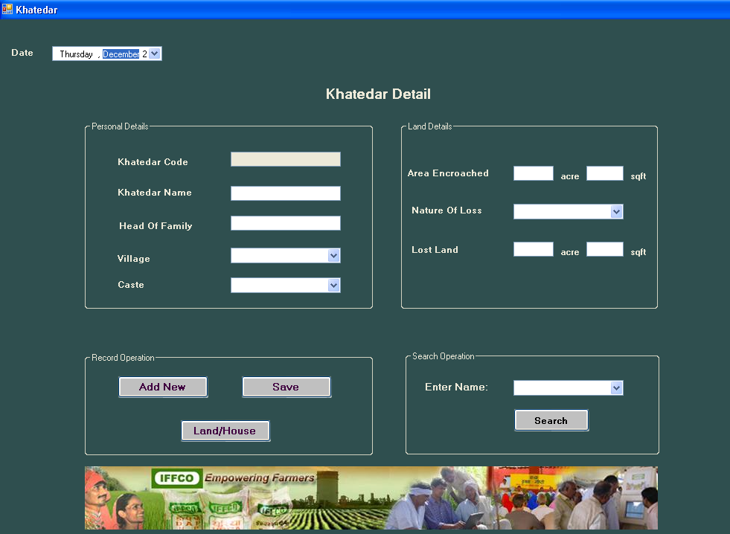
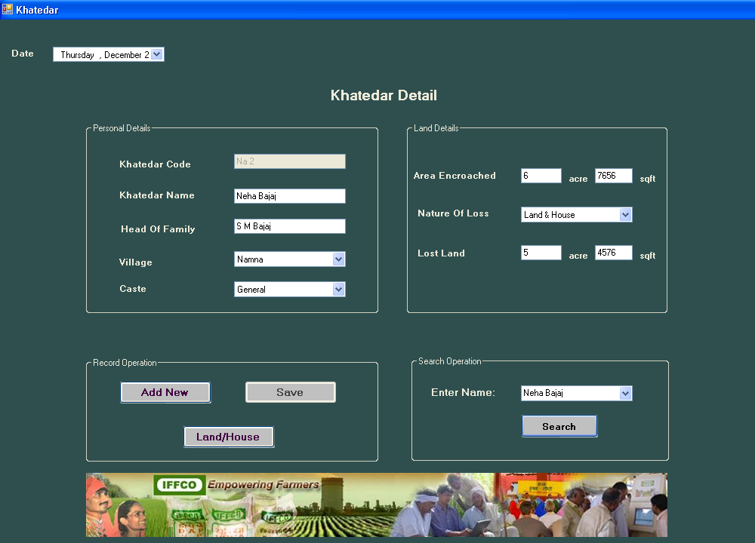

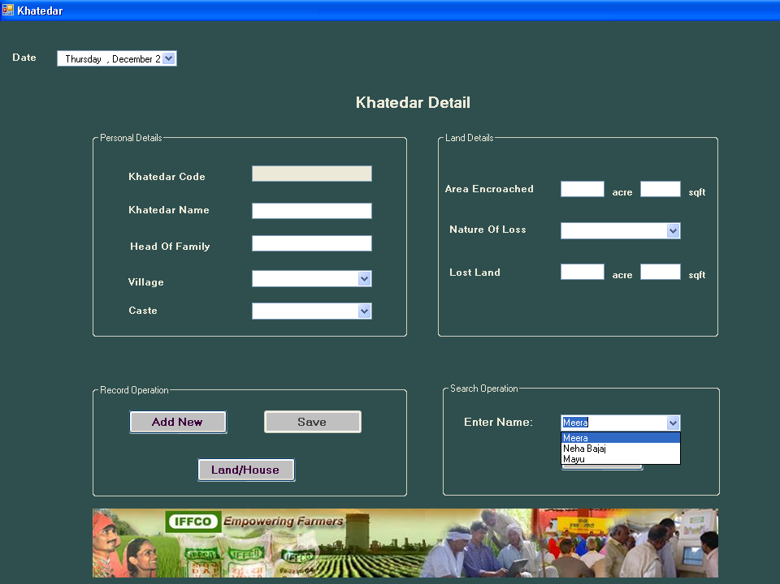

  - House Detail Form
- Here if the khatedar owns a house then only he is directed to this form.
- All details related to house like number of rooms, lavatories, bathrooms, kitchen,etc in the house also the type and area of house is to be selected.
- There are three buttons in this form. They are calculate, save, refresh.
- When all the entries have been filled up in the form except that of total amount, then after clicking on “Calculate” button the software calculates amount of money to be paid as compensation depending upon the type of house and rates predecide on different types of houses by the government .
- When “Save” button is clicked all the data gets stored in the database.
- When clicked on “refresh” button all the entries in the form gets refreshed.

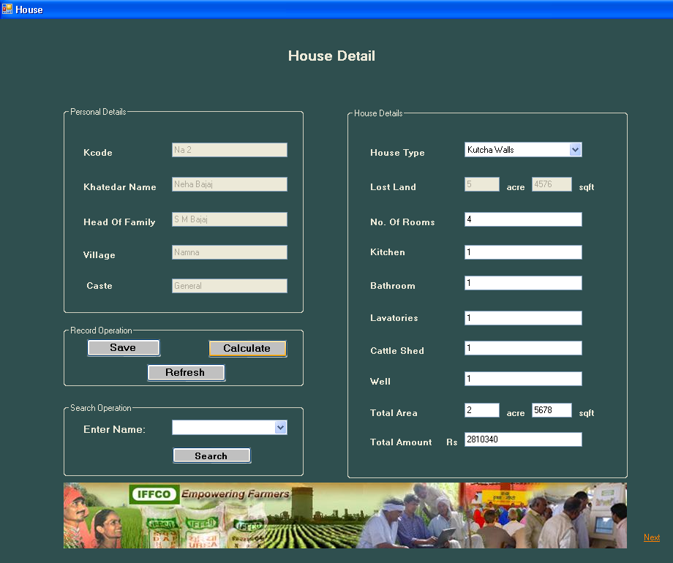
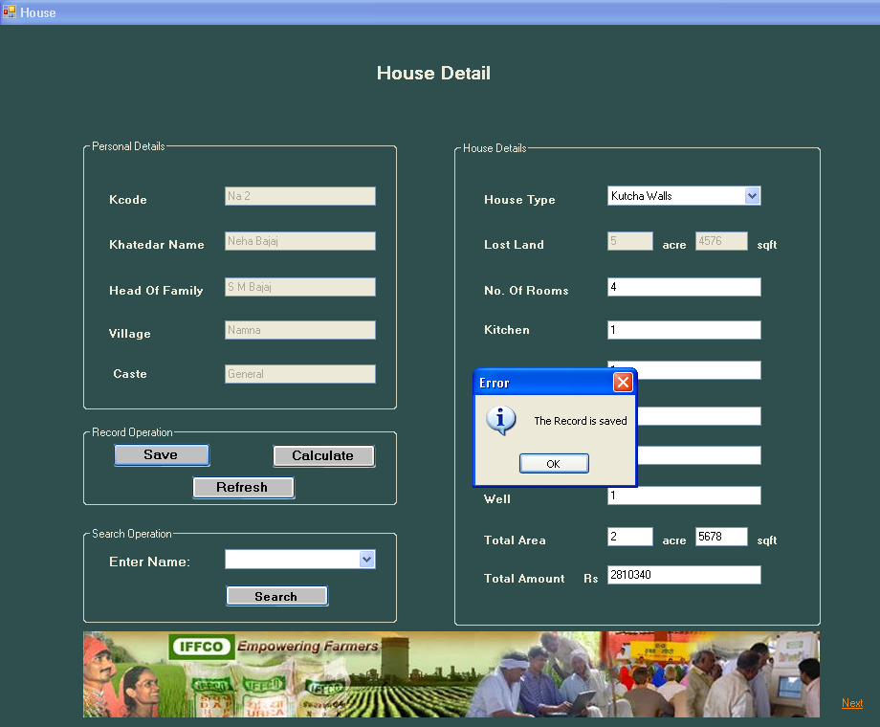
  - Acquired Detail Form
- It contains three operations to be performed.
- It has three buttons i.e. Percentage Loss, Money Compensation, Job Allotment.
- When we click on “Percentage Loss” button, it is checked whether the ratio of lost land to acquired land is greater than 60% or not.
- If it is less than 60% then “Job Allotment” button gets disabled and total amount of money compensation to be given to khatedar is calculated considering land/house by clicking on “Money Compensation” button.
- If it is more than 60% then “Money Compensation” button gets disabled and user is directed to “Job Allotment Form” by clicking on “Job Allotment” button to fill the required details.
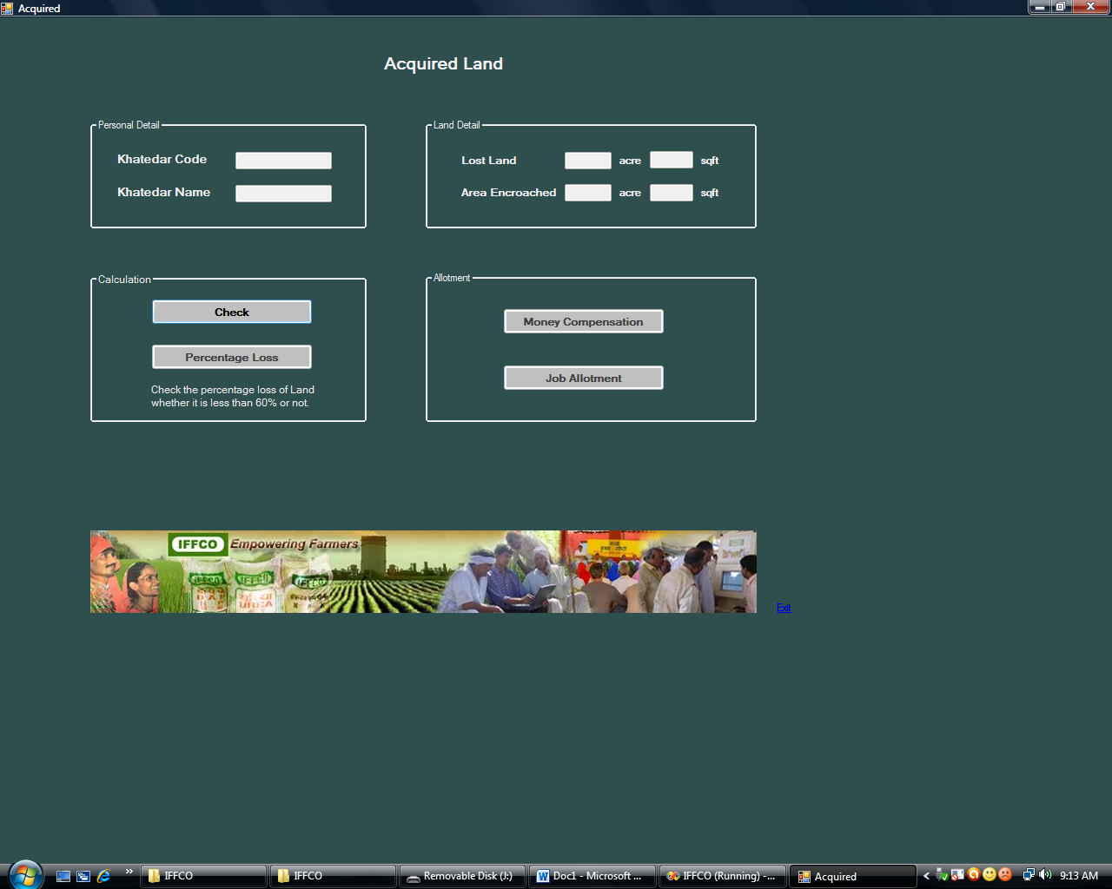

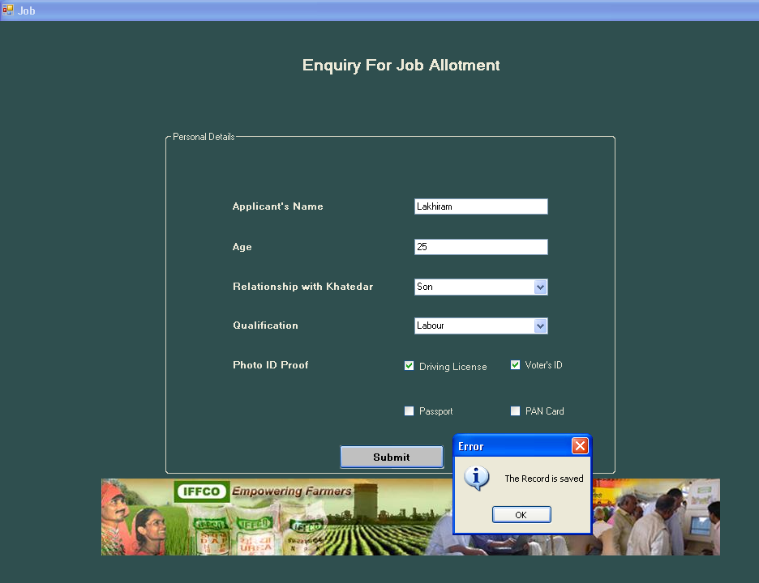

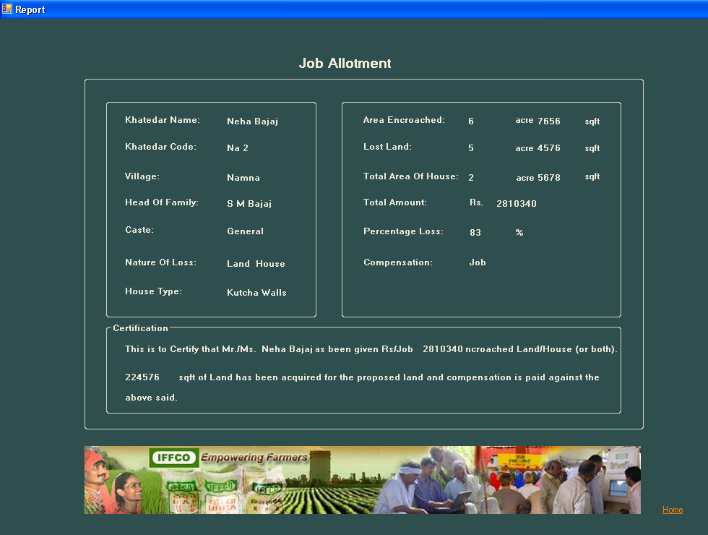

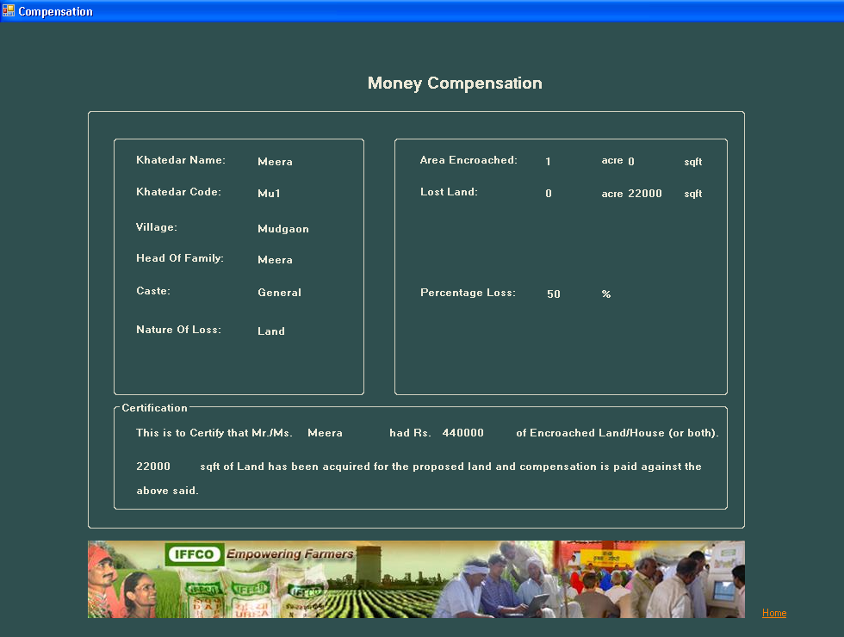

2. Reports
- There are two main reports that can be generated.
- First one is the khatedar detail report.It can be viewed either by khatedar code wise or by khatedar name wise.
- These reports give all the details regarding the personal details of the khatedar.
- Second one is the Compensation detail report. It displays the details of proper compensation given to the khatedar.

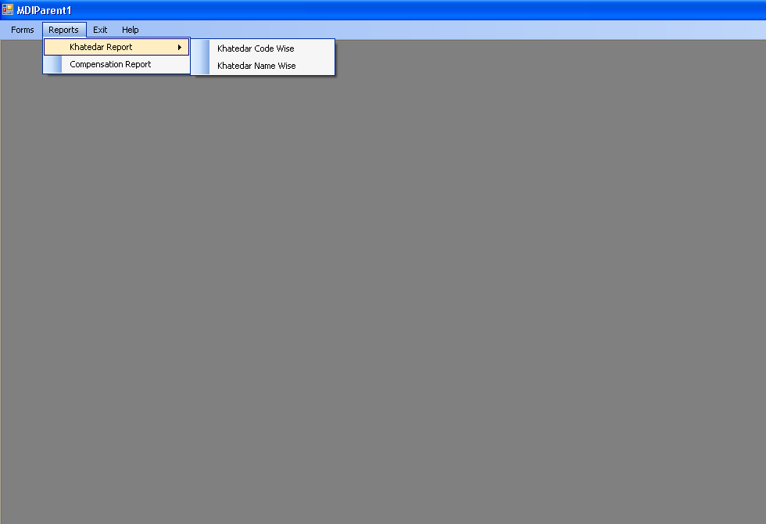
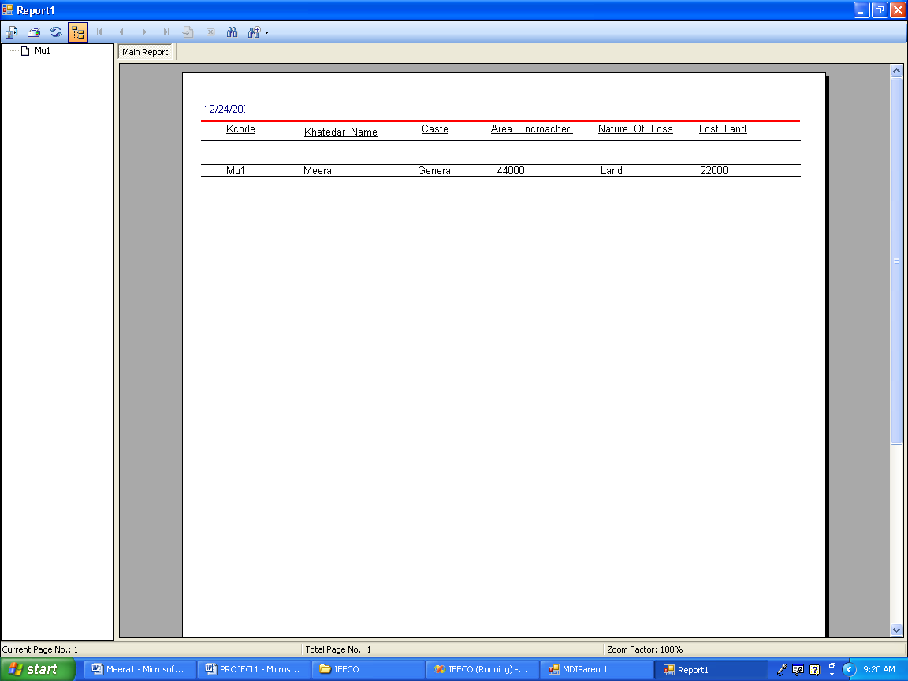

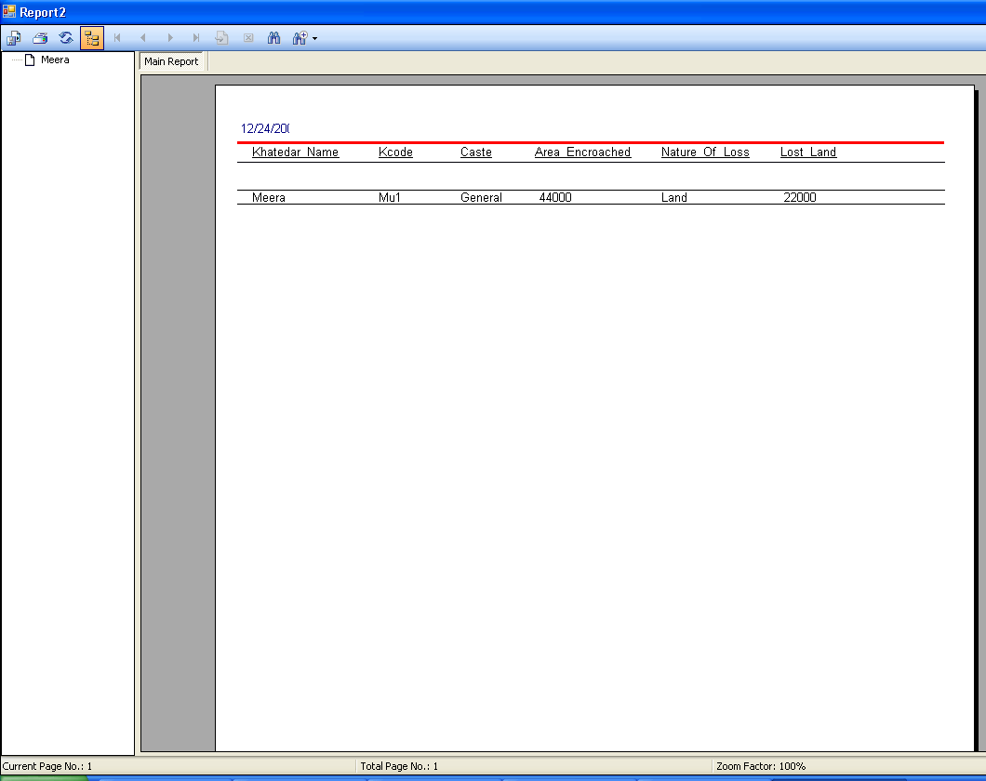

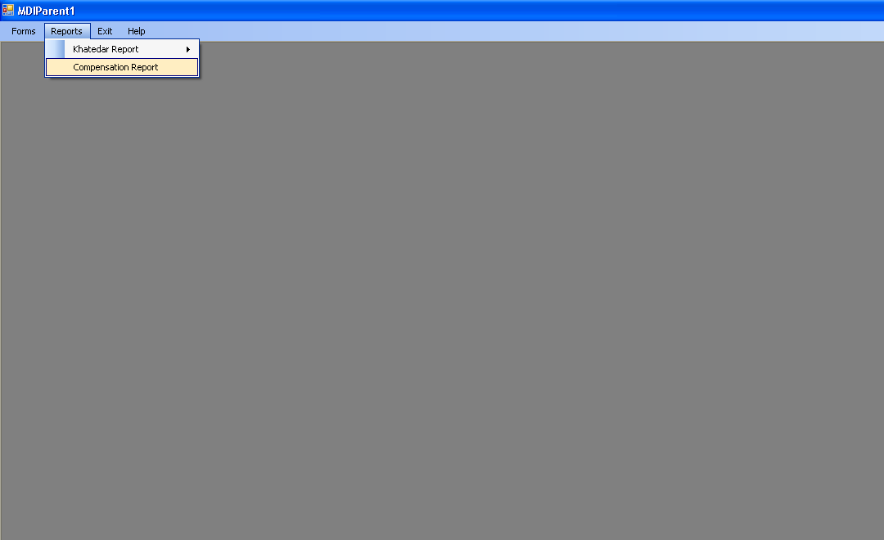

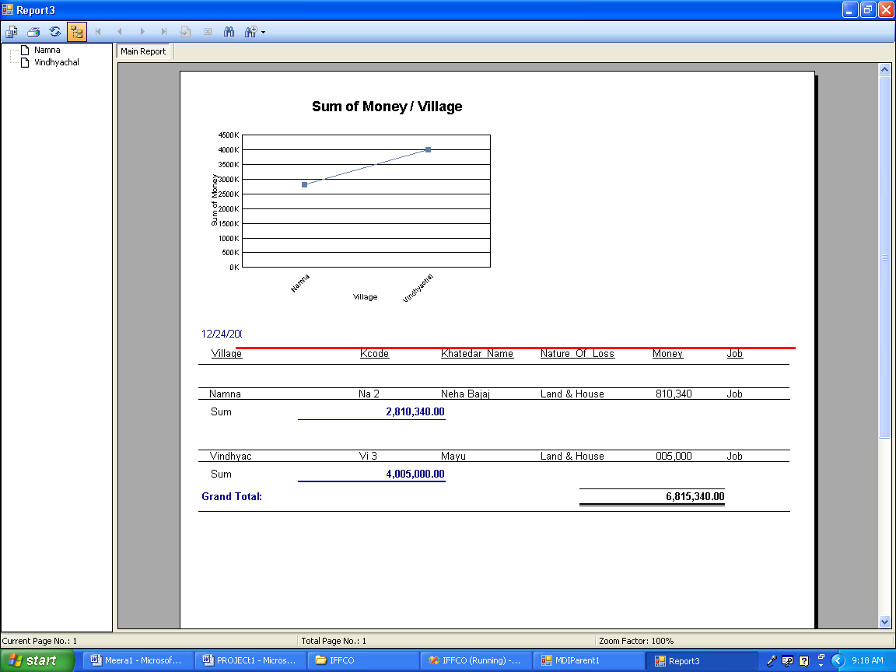

IMPLEMENTATION PHASE

CODING STANDARDS

Coding And Debugging

Once the design is complete, most of the major decisions about the system have been made. However, many of the details about coding the design, which often depend on the programming language chosen, are not specified during the design. The goal of the Coding phase is to translate the design of the system into code in a given programming language. For a given design, the aim in this phase is to implement the design in the best possible manner. The coding phase affects both the Testing and the Maintenance profoundly. Well-written code can reduce the testing and the maintenance effort. The goal of the coding is to reduce the testing and maintenance effort because the testing and the maintenance costs of the software are much higher as compared to the coding cost.

Coding Techniques
It includes -
1) Single Entry, Single Exit constructs,
2) Data Encapsulation,
3) GOTO statements,
4) Recursion
We have mainly used the first type of coding technique in our project. This is the simplest of all technique and meets the requirements of our project
Single Entry, Single Exit constructs: - All the statements in these type of constructs can only be represented in three basic forms – a) Sequencing, b) Selection, c) Iteration.
Sequencing Selection Iteration
C
S1

S2
C
S1
True
False
True
False

S2
S1
S2
S3

Tips of good coding technique

The goal of good coding style is to provide easily understood, straightforward and elegant code. Following are some Do’s that can be followed during coding.

1. Using standard control constructs: - While coding the major part is covered by using statement sequences, selection among alternatives and a mechanism for iteration. So for all these procedures there are some standard constructs provided in the programming language itself hence its advised to use them rather creating a custom made method. This will make the coding more uniform, easier to read, easier to understand.

2. Apply user defined data types to represent entities in the problem area: - Use of distinct data types makes it possible for humans and computer system to distinguish between entities from the problem domain. User defined data type that segment the problem domain in a logical manner can greatly improve the clarity and readability of a source program. Under strong type checking rules, user defined data type also provide increased data security.

3. Carefully examine routines having less than 5 or more than 25 statements: - A subprogram that has less than 5 statements is usually too small to provide a well defined function, it is usually preferable to insert five or less statements in line as needed rather than creating a sub program and calling it. It has been suggested that 30 executable statements is the upper limit to constitute a subprogram. A routine having less than 5 or more than 25 executable statements should be closely examined for in line placement in the calling routines (less than 5 statements), and identification of well defined sub-functions that can be placed in separate routines and called as needed (more than 25 statements).

CODING

Imports System.Windows.Forms
Imports VB = Microsoft.VisualBasic
Public Class MDIParent1
Dim a As String
Dim c As New ADODB.Connection
Dim r As New ADODB.Recordset
Dim r1 As New ADODB.Recordset
Dim n As Integer = 0
Dim p As Integer = 0
Private Sub ExitToolsStripMenuItem_Click(ByVal sender As Object, ByVal e As EventArgs) Handles ExitToolStripMenuItem.Click
Me.Close()
End Sub
Private Sub CloseAllToolStripMenuItem_Click(ByVal sender As Object, ByVal e As EventArgs)
' Close all child forms of the parent.
For Each ChildForm As Form In Me.MdiChildren
ChildForm.Close()
Next
End Sub
Private Sub MDIParent1_Load(ByVal sender As System.Object, ByVal e As System.EventArgs) Handles MyBase.Load
c.ConnectionString = "Provider=microsoft.jet.oledb.4.0;data source=C:\IFFCO\IFFCO.mdb"
c.Open()
r.Open("KHATEDAR", c, ADODB.CursorTypeEnum.adOpenDynamic, ADODB.LockTypeEnum.adLockOptimistic)
r1.Open("House_Detail", c, ADODB.CursorTypeEnum.adOpenDynamic, ADODB.LockTypeEnum.adLockOptimistic)
End Sub
Private Sub SaveAsToolStripMenuItem_Click(ByVal sender As System.Object, ByVal e As System.EventArgs) Handles SaveAsToolStripMenuItem.Click
a = InputBox("Enter Khatedar Code:")
r.MoveFirst()
While r.EOF = False
If a = r.Fields("Kcode").Value Then
n = 1
Exit While
Else
n = 0
End If
r.MoveNext()
End While

If n = 1 Then
Acquired.TextBox1.Text = r.Fields("Kcode").Value
Acquired.TextBox2.Text = r.Fields("Khatedar_Name").Value
Acquired.TextBox4.Text = r.Fields("LL(acre)").Value
Acquired.TextBox6.Text = r.Fields("LL(sqft)").Value
Acquired.TextBox5.Text = r.Fields("AE(acre)").Value
Acquired.TextBox3.Text = r.Fields("AE(sqft)").Value
Acquired.Show()
Me.Hide()
End If

End Sub
Private Sub ToolStripMenuItem1_Click(ByVal sender As System.Object, ByVal e As System.EventArgs) Handles ToolStripMenuItem1.Click
Khatedar.Show()
Me.Hide()
End Sub
Private Sub ToolStripMenuItem2_Click(ByVal sender As System.Object, ByVal e As System.EventArgs) Handles ToolStripMenuItem2.Click
a = InputBox("Enter Khatedar Code:")
r.MoveFirst()
r1.MoveFirst()
While r.EOF = False
If a = r.Fields("Kcode").Value Then
n = 1
Exit While
Else
n = 0
End If
r.MoveNext()
End While
If n = 1 Then
If r.Fields("Nature_Of_Loss").Value = "Land" Then
MsgBox("You can not go to House Form")

ElseIf r.Fields("Nature_Of_Loss").Value = "Land & House" Then
While r1.EOF = False
If a = r1.Fields("Kcode").Value Then
p = 1
Exit While
Else
p = 0
End If
r1.MoveNext()
End While
End If

ElseIf n = 0 Then
MsgBox("Record is not found.")
End If
If p = 1 Then
House.TextBox1.Text = r.Fields("Kcode").Value
House.TextBox2.Text = r.Fields("Khatedar_Name").Value
House.TextBox3.Text = r.Fields("HOF").Value
House.TextBox4.Text = r.Fields("Village").Value
House.TextBox5.Text = r.Fields("Caste").Value
House.TextBox6.Text = r.Fields("LL(acre)").Value
House.TextBox16.Text = r.Fields("LL(sqft)").Value
House.ComboBox1.Text = r1.Fields("House_Type").Value
House.TextBox7.Text = r1.Fields("No_Of_Rooms").Value
House.TextBox8.Text = r1.Fields("Kitchen").Value
House.TextBox9.Text = r1.Fields("Bathroom").Value
House.TextBox10.Text = r1.Fields("Lavatories").Value
House.TextBox11.Text = r1.Fields("Cattle_Shed").Value
House.TextBox12.Text = r1.Fields("Well").Value
House.TextBox13.Text = r1.Fields("TA(acre)").Value
House.TextBox15.Text = r1.Fields("TA(sqft)").Value
House.TextBox14.Text = r1.Fields("Total_Amount").Value

House.TextBox1.Enabled = False
House.TextBox2.Enabled = False
House.TextBox3.Enabled = False
House.TextBox4.Enabled = False
House.TextBox5.Enabled = False
House.TextBox6.Enabled = False
House.TextBox7.Enabled = False
House.TextBox8.Enabled = False
House.TextBox9.Enabled = False
House.TextBox10.Enabled = False
House.TextBox11.Enabled = False
House.TextBox12.Enabled = False
House.TextBox13.Enabled = False
House.TextBox14.Enabled = False
House.TextBox15.Enabled = False
House.TextBox16.Enabled = False
House.ComboBox1.Enabled = False

House.Button1.Enabled = False
House.Button2.Enabled = False
House.Button3.Enabled = False
House.Show()
Me.Hide()
Else
House.TextBox1.Text = r.Fields("Kcode").Value
House.TextBox2.Text = r.Fields("Khatedar_Name").Value
House.TextBox3.Text = r.Fields("HOF").Value
House.TextBox4.Text = r.Fields("Village").Value
House.TextBox5.Text = r.Fields("Caste").Value
House.TextBox6.Text = r.Fields("LL(acre)").Value
House.TextBox16.Text = r.Fields("LL(sqft)").Value

House.Show()
Me.Hide()
End If
End Sub

Private Sub KhatedarCodeWiseToolStripMenuItem_Click(ByVal sender As System.Object, ByVal e As System.EventArgs) Handles KhatedarCodeWiseToolStripMenuItem.Click
Report1.Show()
End Sub

Private Sub KhatedarNameWiseToolStripMenuItem_Click(ByVal sender As System.Object, ByVal e As System.EventArgs) Handles KhatedarNameWiseToolStripMenuItem.Click
Report2.Show()
End Sub

Private Sub CompensationReportToolStripMenuItem_Click(ByVal sender As System.Object, ByVal e As System.EventArgs) Handles CompensationReportToolStripMenuItem.Click
Report3.Show()
End Sub

Private Sub ViewMenu_Click(ByVal sender As System.Object, ByVal e As System.EventArgs) Handles ViewMenu.Click
End
End Sub

Private Sub HelpMenu_Click(ByVal sender As System.Object, ByVal e As System.EventArgs) Handles HelpMenu.Click

End Sub
End Class

Imports VB = Microsoft.VisualBasic
Public Class Khatedar
Dim c As New ADODB.Connection
Dim r As New ADODB.Recordset
Dim dt As String
Dim A As String
Dim K As String

Private Sub Khatedar_Load(ByVal sender As System.Object, ByVal e As System.EventArgs) Handles MyBase.Load
c.ConnectionString = "Provider=microsoft.jet.oledb.4.0;data source=C:\IFFCO\IFFCO.mdb"
c.Open()
r.Open("KHATEDAR", c, ADODB.CursorTypeEnum.adOpenDynamic, ADODB.LockTypeEnum.adLockOptimistic)
'DateTimePicker1.Value = Now
ComboBox2.Items.Add("Shivnagar")
ComboBox2.Items.Add("Mahora")
ComboBox2.Items.Add("Mudgaon")
ComboBox2.Items.Add("Sarastal")
ComboBox2.Items.Add("Namna")
ComboBox2.Items.Add("Vindhyachal")
ComboBox2.Items.Add("Rambora")
ComboBox2.Items.Add("Tikrapara")

ComboBox1.Items.Add("SC")
ComboBox1.Items.Add("ST")
ComboBox1.Items.Add("General")
ComboBox1.Items.Add("OBC")
ComboBox1.Items.Add("Minority")

ComboBox3.Items.Add("Land")
ComboBox3.Items.Add("Land & House")

'DateTimePicker1.Value = Now
r.MoveFirst()
While r.EOF = False
ComboBox4.Items.Add(r.Fields("Khatedar_Name").Value)
r.MoveNext()
End While
End Sub

Private Sub Button1_Click(ByVal sender As System.Object, ByVal e As System.EventArgs) Handles Button1.Click
TextBox1.Text = ""
TextBox2.Text = ""
TextBox3.Text = ""
TextBox4.Text = ""
TextBox5.Text = ""
TextBox6.Text = ""
TextBox7.Text = ""
ComboBox1.Text = Nothing
ComboBox2.Text = Nothing
ComboBox3.Text = Nothing
End Sub

Private Sub Button2_Click(ByVal sender As System.Object, ByVal e As System.EventArgs) Handles Button2.Click
If TextBox2.Text = "" Or TextBox3.Text = "" Or TextBox4.Text = "" Or TextBox5.Text = "" Or TextBox6.Text = "" Or TextBox7.Text = "" Or ComboBox1.Text = Nothing Or ComboBox2.Text = Nothing Or ComboBox3.Text = Nothing Then
MessageBox.Show("Please fill all the fields")
Else

Dim P As String
r.MoveLast()
P = r.Fields("KCODE").Value
Dim D As String
D = ComboBox2.SelectedItem
Dim E1 As String
Dim E2 As String
E1 = VB.Left(D, 2)
E2 = Mid(P, 3, 4)
E2 = E2 + 1
r.AddNew()
r.Fields("KCODE").Value = E1 + Str(E2)
TextBox1.Text = r.Fields("KCODE").Value

r.Fields("Khatedar_Name").Value = TextBox2.Text
r.Fields("HOF").Value = TextBox3.Text
r.Fields("Village").Value = ComboBox2.Text
r.Fields("Caste").Value = ComboBox1.Text
r.Fields("Area_Encroached").Value = Val(TextBox4.Text) * 44000 + Val(TextBox6.Text)
r.Fields("Nature_Of_Loss").Value = ComboBox3.Text
r.Fields("Lost_Land").Value = Val(TextBox5.Text) * 44000 + Val(TextBox7.Text)
r.Fields("AE(acre)").Value = TextBox4.Text
r.Fields("AE(sqft)").Value = TextBox6.Text
r.Fields("LL(acre)").Value = TextBox5.Text
r.Fields("LL(sqft)").Value = TextBox7.Text

' r.Fields("DATE1").Value = dt

MessageBox.Show("The Record is saved", A, MessageBoxButtons.OK, MessageBoxIcon.Information)
MessageBox.Show("Khatedar Code is:" & r.Fields("KCODE").Value, A, MessageBoxButtons.OK, MessageBoxIcon.Information)
r.Save()
Button2.Enabled = False
End If
End Sub

Private Sub DateTimePicker1_CloseUp(ByVal sender As Object, ByVal e As System.EventArgs) Handles DateTimePicker1.CloseUp
'dt = DateTimePicker1.Value.ToString
End Sub

Private Sub Button3_Click(ByVal sender As System.Object, ByVal e As System.EventArgs) Handles Button3.Click
r.MoveFirst()
While r.EOF = False
If ComboBox4.SelectedItem = r.Fields("Khatedar_Name").Value Then
TextBox1.Text = r.Fields("KCODE").Value
TextBox2.Text = r.Fields("Khatedar_Name").Value
TextBox3.Text = r.Fields("HOF").Value
ComboBox2.Text = r.Fields("Village").Value
ComboBox1.Text = r.Fields("Caste").Value
TextBox4.Text = r.Fields("AE(acre)").Value
ComboBox3.Text = r.Fields("Nature_Of_Loss").Value
TextBox6.Text = r.Fields("AE(sqft)").Value
TextBox5.Text = r.Fields("LL(acre)").Value
TextBox7.Text = r.Fields("LL(sqft)").Value
End If
r.MoveNext()
End While
Button2.Enabled = False

End Sub

Private Sub TextBox4_KeyPress(ByVal sender As Object, ByVal e As System.Windows.Forms.KeyPressEventArgs) Handles TextBox4.KeyPress
If Char.IsDigit(e.KeyChar) = False And Char.IsControl(e.KeyChar) = False Then
e.Handled = True
MsgBox("Please enter valid number ")
End If
End Sub

Private Sub TextBox5_KeyPress(ByVal sender As Object, ByVal e As System.Windows.Forms.KeyPressEventArgs) Handles TextBox5.KeyPress
If Char.IsDigit(e.KeyChar) = False And Char.IsControl(e.KeyChar) = False Then
e.Handled = True
MsgBox("Please enter valid number ")
End If
End Sub

Private Sub TextBox6_KeyPress(ByVal sender As Object, ByVal e As System.Windows.Forms.KeyPressEventArgs) Handles TextBox6.KeyPress
If Char.IsDigit(e.KeyChar) = False And Char.IsControl(e.KeyChar) = False Then
e.Handled = True
MsgBox("Please enter valid number ")
End If
End Sub

Private Sub TextBox7_KeyPress(ByVal sender As Object, ByVal e As System.Windows.Forms.KeyPressEventArgs) Handles TextBox7.KeyPress
If Char.IsDigit(e.KeyChar) = False And Char.IsControl(e.KeyChar) = False Then
e.Handled = True
MsgBox("Please enter valid number ")
End If
End Sub

Private Sub Button4_Click(ByVal sender As System.Object, ByVal e As System.EventArgs) Handles Button4.Click
If ComboBox3.SelectedItem = "Land" Then
Acquired.Show()
r.MoveFirst()
While r.EOF = False
If TextBox1.Text = r.Fields("kcode").Value Then
Acquired.TextBox1.Text = r.Fields("Kcode").Value
Acquired.TextBox2.Text = r.Fields("Khatedar_Name").Value
Acquired.TextBox4.Text = r.Fields("LL(acre)").Value
Acquired.TextBox6.Text = r.Fields("LL(sqft)").Value
Acquired.TextBox5.Text = r.Fields("AE(acre)").Value
Acquired.TextBox3.Text = r.Fields("AE(sqft)").Value
End If
r.MoveNext()
End While

ElseIf ComboBox3.SelectedItem = "Land & House" Then
House.Show()
House.TextBox1.Text = TextBox1.Text

r.MoveFirst()
While r.EOF = False
If House.TextBox1.Text = r.Fields("kcode").Value Then
House.TextBox2.Text = r.Fields("Khatedar_Name").Value
House.TextBox3.Text = r.Fields("HOF").Value
House.TextBox4.Text = r.Fields("Village").Value
House.TextBox5.Text = r.Fields("Caste").Value
House.TextBox6.Text = r.Fields("LL(acre)").Value
House.TextBox16.Text = r.Fields("LL(sqft)").Value
End If
r.MoveNext()
End While
End If
End Sub
End Class

Public Class House
Dim c As New ADODB.Connection
Dim r As New ADODB.Recordset
Dim r1 As New ADODB.Recordset
Dim r2 As New ADODB.Recordset
Dim A As String
Dim p As Integer

Private Sub House_Activated(ByVal sender As Object, ByVal e As System.EventArgs) Handles Me.Activated

End Sub

Private Sub House_Load(ByVal sender As System.Object, ByVal e As System.EventArgs) Handles MyBase.Load
c.ConnectionString = "Provider=microsoft.jet.oledb.4.0;data source=C:\IFFCO\IFFCO.mdb"
c.Open()
r.Open("KHATEDAR", c, ADODB.CursorTypeEnum.adOpenDynamic, ADODB.LockTypeEnum.adLockOptimistic)
r1.Open("House_Detail", c, ADODB.CursorTypeEnum.adOpenDynamic, ADODB.LockTypeEnum.adLockOptimistic)
r2.Open("House", c, ADODB.CursorTypeEnum.adOpenDynamic, ADODB.LockTypeEnum.adLockOptimistic)

ComboBox1.Items.Add("Kutcha Walls")
ComboBox1.Items.Add("Kutcha Walls With Tiled Roof")
ComboBox1.Items.Add("Kutcha Walls With Thached Roof")
ComboBox1.Items.Add("Fully Pukka")

r1.MoveFirst()
While r1.EOF = False
ComboBox4.Items.Add(r1.Fields("Khatedar_Name").Value)
r1.MoveNext()
End While

End Sub

Private Sub Button1_Click(ByVal sender As System.Object, ByVal e As System.EventArgs) Handles Button1.Click
If ComboBox1.SelectedItem = Nothing Or TextBox6.Text = "" Or TextBox16.Text = "" Or TextBox7.Text = "" Or TextBox8.Text = "" Or TextBox9.Text = "" Or TextBox10.Text = "" Or TextBox11.Text = "" Or TextBox13.Text = "" Or TextBox15.Text = "" Or TextBox14.Text = "" Then
MessageBox.Show("Please Fill all the fields")
Else
r1.AddNew()
r1.Fields("Kcode").Value = TextBox1.Text
r1.Fields("Village").Value = TextBox4.Text
r1.Fields("Khatedar_Name").Value = TextBox2.Text
r1.Fields("HOF").Value = TextBox3.Text
r1.Fields("Caste").Value = TextBox5.Text
r1.Fields("Lost_Land").Value = TextBox6.Text
r1.Fields("House_Type").Value = ComboBox1.SelectedItem
r1.Fields("No_of_Rooms").Value = TextBox7.Text
r1.Fields("Kitchen").Value = TextBox8.Text
r1.Fields("Bathroom").Value = TextBox9.Text
r1.Fields("Lavatories").Value = TextBox10.Text
r1.Fields("Cattle_Shed").Value = TextBox11.Text
r1.Fields("Well").Value = TextBox12.Text
r1.Fields("TA(acre)").Value = TextBox13.Text
r1.Fields("TA(sqft)").Value = TextBox15.Text
r1.Fields("Total_Area").Value = Val(TextBox13.Text) * 44000 + Val(TextBox15.Text)
r1.Fields("Total_Amount").Value = TextBox14.Text
r1.Save()
MessageBox.Show("The Record is saved", A, MessageBoxButtons.OK, MessageBoxIcon.Information)
Button1.Enabled = False
End If
End Sub

Private Sub Button2_Click(ByVal sender As System.Object, ByVal e As System.EventArgs) Handles Button2.Click
p = (Val(TextBox13.Text) * 44000) + Val(TextBox15.Text)
r2.MoveFirst()
While r2.EOF = False
If ComboBox1.Text = r2.Fields("House_Type").Value Then
TextBox14.Text = r2.Fields("Amount").Value * p
End If
r2.MoveNext()
End While
End Sub

Private Sub Button3_Click(ByVal sender As System.Object, ByVal e As System.EventArgs) Handles Button3.Click
r1.MoveFirst()
While r1.EOF = False
If ComboBox4.SelectedItem = r1.Fields("Khatedar_Name").Value Then
TextBox1.Text = r1.Fields("Kcode").Value
TextBox2.Text = r1.Fields("Khatedar_Name").Value
TextBox3.Text = r1.Fields("HOF").Value
TextBox4.Text = r1.Fields("Village").Value
TextBox5.Text = r1.Fields("Caste").Value
ComboBox1.Text = r1.Fields("House_Type").Value
TextBox6.Text = r.Fields("LL(acre)").Value
TextBox16.Text = r.Fields("LL(sqft)").Value
TextBox7.Text = r1.Fields("No_of_Rooms").Value
TextBox8.Text = r1.Fields("Kitchen").Value
TextBox9.Text = r1.Fields("Bathroom").Value
TextBox10.Text = r1.Fields("Lavatories").Value
TextBox11.Text = r1.Fields("Cattle_Shed").Value
TextBox12.Text = r1.Fields("Well").Value
TextBox13.Text = r1.Fields("TA(acre)").Value
TextBox15.Text = r1.Fields("TA(sqft)").Value
TextBox14.Text = r1.Fields("Total_Amount").Value
End If
r1.MoveNext()
End While
Button2.Enabled = False

End Sub

Private Sub TextBox7_KeyPress(ByVal sender As Object, ByVal e As System.Windows.Forms.KeyPressEventArgs) Handles TextBox7.KeyPress
If Char.IsDigit(e.KeyChar) = False And Char.IsControl(e.KeyChar) = False Then
e.Handled = True
MsgBox("Please enter valid number ")
End If
End Sub

Private Sub TextBox8_KeyPress(ByVal sender As Object, ByVal e As System.Windows.Forms.KeyPressEventArgs) Handles TextBox8.KeyPress
If Char.IsDigit(e.KeyChar) = False And Char.IsControl(e.KeyChar) = False Then
e.Handled = True
MsgBox("Please enter valid number ")
End If
End Sub

Private Sub TextBox9_KeyPress(ByVal sender As Object, ByVal e As System.Windows.Forms.KeyPressEventArgs) Handles TextBox9.KeyPress
If Char.IsDigit(e.KeyChar) = False And Char.IsControl(e.KeyChar) = False Then
e.Handled = True
MsgBox("Please enter valid number ")
End If
End Sub

Private Sub TextBox10_KeyPress(ByVal sender As Object, ByVal e As System.Windows.Forms.KeyPressEventArgs) Handles TextBox10.KeyPress
If Char.IsDigit(e.KeyChar) = False And Char.IsControl(e.KeyChar) = False Then
e.Handled = True
MsgBox("Please enter valid number ")
End If
End Sub
Private Sub TextBox11_KeyPress(ByVal sender As Object, ByVal e As System.Windows.Forms.KeyPressEventArgs) Handles TextBox11.KeyPress
If Char.IsDigit(e.KeyChar) = False And Char.IsControl(e.KeyChar) = False Then
e.Handled = True
MsgBox("Please enter valid number ")
End If
End Sub
Private Sub TextBox12_KeyPress(ByVal sender As Object, ByVal e As System.Windows.Forms.KeyPressEventArgs) Handles TextBox12.KeyPress
If Char.IsDigit(e.KeyChar) = False And Char.IsControl(e.KeyChar) = False Then
e.Handled = True
MsgBox("Please enter valid number ")
End If
End Sub

Private Sub TextBox13_KeyPress(ByVal sender As Object, ByVal e As System.Windows.Forms.KeyPressEventArgs) Handles TextBox13.KeyPress
If Char.IsDigit(e.KeyChar) = False And Char.IsControl(e.KeyChar) = False Then
e.Handled = True
MsgBox("Please enter valid number ")
End If
End Sub

Private Sub TextBox15_KeyPress(ByVal sender As Object, ByVal e As System.Windows.Forms.KeyPressEventArgs) Handles TextBox15.KeyPress
If Char.IsDigit(e.KeyChar) = False And Char.IsControl(e.KeyChar) = False Then
e.Handled = True
MsgBox("Please enter valid number ")
End If
End Sub

Private Sub ComboBox4_KeyPress(ByVal sender As Object, ByVal e As System.Windows.Forms.KeyPressEventArgs) Handles ComboBox4.KeyPress
If Char.IsDigit(e.KeyChar) = False And Char.IsControl(e.KeyChar) = False Then
e.Handled = True
MsgBox("Please enter valid number ")
End If
End Sub

Private Sub TextBox6_KeyPress(ByVal sender As Object, ByVal e As System.Windows.Forms.KeyPressEventArgs) Handles TextBox6.KeyPress
If Char.IsDigit(e.KeyChar) = False And Char.IsControl(e.KeyChar) = False Then
e.Handled = True
MsgBox("Please enter valid number ")
End If
End Sub
Private Sub Button4_Click(ByVal sender As System.Object, ByVal e As System.EventArgs) Handles Button4.Click
TextBox1.Text = Nothing
TextBox2.Text = Nothing
TextBox3.Text = Nothing
TextBox4.Text = Nothing
TextBox5.Text = Nothing
ComboBox1.Text = Nothing
TextBox6.Text = Nothing
TextBox16.Text = Nothing
TextBox7.Text = Nothing
TextBox8.Text = Nothing
TextBox9.Text = Nothing
TextBox10.Text = Nothing
TextBox11.Text = Nothing
TextBox12.Text = Nothing
TextBox13.Text = Nothing
TextBox15.Text = Nothing
TextBox14.Text = Nothing
End Sub

Private Sub Button5_Click(ByVal sender As System.Object, ByVal e As System.EventArgs)
Acquired.Show()
End Sub

Private Sub LinkLabel1_LinkClicked(ByVal sender As System.Object, ByVal e As System.Windows.Forms.LinkLabelLinkClickedEventArgs) Handles LinkLabel1.LinkClicked
Acquired.Show()
r.MoveFirst()
While r.EOF = False
If TextBox1.Text = r.Fields("kcode").Value Then
Acquired.TextBox1.Text = r.Fields("Kcode").Value
Acquired.TextBox2.Text = r.Fields("Khatedar_Name").Value
Acquired.TextBox4.Text = r.Fields("LL(acre)").Value
Acquired.TextBox6.Text = r.Fields("LL(sqft)").Value
Acquired.TextBox5.Text = r.Fields("AE(acre)").Value
Acquired.TextBox3.Text = r.Fields("AE(sqft)").Value
End If
r.MoveNext()
End While
End Sub
End Class
Public Class Acquired
Dim c As New ADODB.Connection
Dim r As New ADODB.Recordset
Dim r1 As New ADODB.Recordset
Dim r2 As New ADODB.Recordset
Dim r3 As New ADODB.Recordset
Dim p As Integer
Dim m As Double
Dim j As Integer
Dim A As String
Dim z As Boolean = False
Dim flag As Boolean = False

Private Sub Acquired_Activated(ByVal sender As Object, ByVal e As System.EventArgs) Handles Me.Activated

End Sub

Private Sub Acquired_Load(ByVal sender As System.Object, ByVal e As System.EventArgs) Handles MyBase.Load
c.ConnectionString = "Provider=microsoft.jet.oledb.4.0;data source=C:\IFFCO\IFFCO.mdb"
c.Open()
r1.Open("Acquired", c, ADODB.CursorTypeEnum.adOpenDynamic, ADODB.LockTypeEnum.adLockOptimistic)
r3.Open("Compensation", c, ADODB.CursorTypeEnum.adOpenDynamic, ADODB.LockTypeEnum.adLockOptimistic)

'TextBox1.Text = r.Fields("Kcode").Value
'TextBox2.Text = r.Fields("Khatedar_Name").Value
'TextBox4.Text = r.Fields("LL(acre)").Value
'TextBox6.Text = r.Fields("LL(sqft)").Value
'TextBox5.Text = r.Fields("AE(acre)").Value
'TextBox3.Text = r.Fields("AE(sqft)").Value

End Sub
Private Sub Button1_Click(ByVal sender As System.Object, ByVal e As System.EventArgs) Handles Button1.Click
r.Open("Select * from KHATEDAR where Kcode='" & TextBox1.Text & "'", c, ADODB.CursorTypeEnum.adOpenDynamic, ADODB.LockTypeEnum.adLockOptimistic)
r2.Open("Select * from House_Detail where Kcode='" & TextBox1.Text & "'", c, ADODB.CursorTypeEnum.adOpenDynamic, ADODB.LockTypeEnum.adLockOptimistic)
'r3.Open("Select * from Compensation where Kcode='" & TextBox1.Text & "'", c, ADODB.CursorTypeEnum.adOpenDynamic, ADODB.LockTypeEnum.adLockOptimistic)

If r.Fields("Nature_Of_Loss").Value = "Land" Then
m = r.Fields("Lost_Land").Value * 20
r3.AddNew()
r3.Fields("Kcode").Value = r.Fields("Kcode").Value
r3.Fields("Khatedar_Name").Value = r.Fields("Khatedar_Name").Value
r3.Fields("Nature_Of_Loss").Value = r.Fields("Nature_Of_Loss").Value
r3.Fields("Money").Value = m
r3.Fields("Job").Value = "NA"
r3.Save()
Compensation.Label20.Text = r.Fields("Khatedar_Name").Value
Compensation.Label21.Text = r.Fields("Kcode").Value
Compensation.Label22.Text = r.Fields("Village").Value
Compensation.Label23.Text = r.Fields("HOF").Value
Compensation.Label24.Text = r.Fields("Caste").Value
Compensation.Label25.Text = r.Fields("Nature_Of_Loss").Value
Compensation.Label26.Visible = False
Compensation.Label13.Visible = False
Compensation.Label27.Text = r.Fields("AE(acre)").Value
Compensation.Label28.Text = r.Fields("AE(sqft)").Value
Compensation.Label29.Text = r.Fields("LL(acre)").Value
Compensation.Label30.Text = r.Fields("LL(sqft)").Value
Compensation.Label10.Visible = False
Compensation.Label16.Visible = False
Compensation.Label17.Visible = False
Compensation.Label18.Visible = False
Compensation.Label19.Visible = False
Compensation.Label31.Visible = False
Compensation.Label32.Visible = False
Compensation.Label33.Visible = False
Compensation.Label35.Text = p
Compensation.Label38.Text = r.Fields("Khatedar_Name").Value
Compensation.Label41.Text = m
Compensation.Label43.Text = r.Fields("Lost_Land").Value
ElseIf r.Fields("Nature_Of_Loss").Value = "Land & House" Then
m = r2.Fields("Total_Amount").Value + (r.Fields("Lost_Land").Value * 20)

r3.AddNew()
r3.Fields("Kcode").Value = r.Fields("Kcode").Value
r3.Fields("Khatedar_Name").Value = r.Fields("Khatedar_Name").Value
r3.Fields("Nature_Of_Loss").Value = r.Fields("Nature_Of_Loss").Value
r3.Fields("Money").Value = m
r3.Fields("Job").Value = "NA"
r3.Save()

Compensation.Label20.Text = r.Fields("Khatedar_Name").Value
Compensation.Label21.Text = r.Fields("Kcode").Value
Compensation.Label22.Text = r.Fields("Village").Value
Compensation.Label23.Text = r.Fields("HOF").Value
Compensation.Label24.Text = r.Fields("Caste").Value
Compensation.Label25.Text = r.Fields("Nature_Of_Loss").Value
Compensation.Label26.Text = r2.Fields("House_Type").Value
Compensation.Label27.Text = r.Fields("AE(acre)").Value
Compensation.Label28.Text = r.Fields("AE(sqft)").Value
Compensation.Label29.Text = r.Fields("LL(acre)").Value
Compensation.Label30.Text = r.Fields("LL(sqft)").Value
Compensation.Label31.Text = r2.Fields("TA(acre)").Value
Compensation.Label32.Text = r2.Fields("TA(sqft)").Value
Compensation.Label33.Text = r2.Fields("Total_Amount").Value
Compensation.Label35.Text = p
Compensation.Label38.Text = r.Fields("Khatedar_Name").Value
Compensation.Label41.Text = m
Compensation.Label43.Text = r.Fields("Lost_Land").Value
End If
r1.AddNew()
r1.Fields("Money").Value = m
r1.Fields("Kcode").Value = TextBox1.Text
r1.Fields("Khatedar_Name").Value = TextBox2.Text
r1.Fields("Per_Loss").Value = p
r1.Fields("Job").Value = ""
r1.Save()
Compensation.Show()
r.Close()
r2.Close()
End Sub

Private Sub Button3_Click(ByVal sender As System.Object, ByVal e As System.EventArgs) Handles Button3.Click
r.Open("Select * from KHATEDAR where Kcode='" & TextBox1.Text & "'", c, ADODB.CursorTypeEnum.adOpenDynamic, ADODB.LockTypeEnum.adLockOptimistic)

p = (r.Fields("Lost_Land").Value / r.Fields("Area_Encroached").Value) * 100
MessageBox.Show("Percentage Loss is:" & p & "%", A, MessageBoxButtons.OK, MessageBoxIcon.Information)

If p <= 60 Then
Button2.Enabled = False
Else
Button1.Enabled = False
End If
'r1.Close()
r.Close()
End Sub

Private Sub Button2_Click(ByVal sender As System.Object, ByVal e As System.EventArgs) Handles Button2.Click
r1.AddNew()
r1.Fields("Money").Value = m
r1.Fields("Kcode").Value = TextBox1.Text
r1.Fields("Khatedar_Name").Value = TextBox2.Text
r1.Fields("Per_Loss").Value = p
r1.Fields("Job").Value = "Job"
r1.Save()
r.Open("Select * from KHATEDAR where Kcode='" & TextBox1.Text & "'", c, ADODB.CursorTypeEnum.adOpenDynamic, ADODB.LockTypeEnum.adLockOptimistic)
r2.Open("Select * from House_Detail where Kcode='" & TextBox1.Text & "'", c, ADODB.CursorTypeEnum.adOpenDynamic, ADODB.LockTypeEnum.adLockOptimistic)
'r3.Open("Select * from Compensation where Kcode='" & TextBox1.Text & "'", c, ADODB.CursorTypeEnum.adOpenDynamic, ADODB.LockTypeEnum.adLockOptimistic)

If r.Fields("Nature_Of_Loss").Value = "Land" Then
'm = r.Fields("Lost_Land").Value * 20
r3.AddNew()
r3.Fields("Kcode").Value = r.Fields("Kcode").Value
r3.Fields("Khatedar_Name").Value = r.Fields("Khatedar_Name").Value
r3.Fields("Nature_Of_Loss").Value = r.Fields("Nature_Of_Loss").Value
r3.Fields("Money").Value = 0
r3.Fields("Job").Value = "Job"
r3.Save()
If p >= 60 Then
Report.Label20.Text = r.Fields("Khatedar_Name").Value
Report.Label21.Text = r.Fields("Kcode").Value
Report.Label22.Text = r.Fields("Village").Value
Report.Label23.Text = r.Fields("HOF").Value
Report.Label24.Text = r.Fields("Caste").Value
Report.Label25.Text = r.Fields("Nature_Of_Loss").Value
Report.Label26.Visible = False
Report.Label13.Visible = False
Report.Label27.Text = r.Fields("AE(acre)").Value
Report.Label28.Text = r.Fields("AE(sqft)").Value
Report.Label29.Text = r.Fields("LL(acre)").Value
Report.Label30.Text = r.Fields("LL(sqft)").Value
Report.Label10.Visible = False
Report.Label16.Visible = False
Report.Label17.Visible = False
Report.Label18.Visible = False
Report.Label19.Visible = False
Report.Label31.Visible = False
Report.Label32.Visible = False
Report.Label33.Visible = False
Report.Label35.Text = p
Report.Label38.Text = r.Fields("Khatedar_Name").Value
'Compensation.Label41.Text = m
Report.Label47.Visible = False
Report.Label46.Text = r1.Fields("Job").Value
Report.Label43.Text = r.Fields("Lost_Land").Value
End If
ElseIf r.Fields("Nature_Of_Loss").Value = "Land & House" Then
m = r2.Fields("Total_Amount").Value
r3.AddNew()
r3.Fields("Kcode").Value = r.Fields("Kcode").Value
r3.Fields("Khatedar_Name").Value = r.Fields("Khatedar_Name").Value
r3.Fields("Nature_Of_Loss").Value = r.Fields("Nature_Of_Loss").Value
r3.Fields("Money").Value = m
r3.Fields("Job").Value = "Job"
r3.Save()
If p >= 60 Then
Report.Label20.Text = r.Fields("Khatedar_Name").Value
Report.Label21.Text = r.Fields("Kcode").Value
Report.Label22.Text = r.Fields("Village").Value
Report.Label23.Text = r.Fields("HOF").Value
Report.Label24.Text = r.Fields("Caste").Value
Report.Label25.Text = r.Fields("Nature_Of_Loss").Value
Report.Label26.Text = r2.Fields("House_Type").Value
Report.Label27.Text = r.Fields("AE(acre)").Value
Report.Label28.Text = r.Fields("AE(sqft)").Value
Report.Label29.Text = r.Fields("LL(acre)").Value
Report.Label30.Text = r.Fields("LL(sqft)").Value
Report.Label31.Text = r2.Fields("TA(acre)").Value
Report.Label32.Text = r2.Fields("TA(sqft)").Value
Report.Label33.Text = r2.Fields("Total_Amount").Value
Report.Label35.Text = p
Report.Label46.Text = r1.Fields("Job").Value
Report.Label38.Text = r.Fields("Khatedar_Name").Value
Report.Label47.Text = m
Report.Label43.Text = r.Fields("Lost_Land").Value
End If
End If
r.Close()
r2.Close()
'r3.Close()
Job.Show()
End Sub
End Class

Imports VB = Microsoft.VisualBasic
Public Class Job
Dim c As New ADODB.Connection
Dim r As New ADODB.Recordset
Dim A As String
Dim S As String
Dim m As Integer
Dim flag As Integer = 0
Dim l As Integer

Private Sub Job_Load(ByVal sender As System.Object, ByVal e As System.EventArgs) Handles MyBase.Load
c.ConnectionString = "Provider=microsoft.jet.oledb.4.0;data source=C:\IFFCO\IFFCO.mdb"
c.Open()
r.Open("Job", c, ADODB.CursorTypeEnum.adOpenDynamic, ADODB.LockTypeEnum.adLockOptimistic)

ComboBox1.Items.Add("Himself")
ComboBox1.Items.Add("Herself")
ComboBox1.Items.Add("Son")
ComboBox1.Items.Add("Daughter")
ComboBox1.Items.Add("Grandson")
ComboBox1.Items.Add("Granddaughter")

ComboBox2.Items.Add("Executive")
ComboBox2.Items.Add("Labour")
End Sub

Private Sub Button1_Click(ByVal sender As System.Object, ByVal e As System.EventArgs) Handles Button1.Click
If CheckBox1.Enabled = True Then
TextBox4.Text = "yes"
Else
TextBox4.Text = "no"
End If
If CheckBox2.Enabled = True Then
TextBox5.Text = "yes"
Else
TextBox5.Text = "no"
End If
If CheckBox3.Enabled = True Then
TextBox6.Text = "yes"
Else
TextBox6.Text = "no"
End If
If CheckBox4.Enabled = True Then
TextBox7.Text = "yes"
Else
TextBox7.Text = "no"
End If
If CheckBox1.Enabled = False Or CheckBox2.Enabled = False Or CheckBox3.Enabled = False Or CheckBox4.Enabled = False Then
MessageBox.Show("Photo ID proof")
End If
r.AddNew()
r.Fields("Name").Value = TextBox1.Text
r.Fields("Age").Value = TextBox3.Text
r.Fields("Relation").Value = ComboBox1.SelectedItem
r.Fields("Qualification").Value = ComboBox2.SelectedItem
r.Fields("Driver_License").Value = TextBox4.Text
r.Fields("Voter_ID").Value = TextBox5.Text
r.Fields("Passport").Value = TextBox6.Text
r.Fields("PAN").Value = TextBox7.Text
r.Update()
MessageBox.Show("The Record is saved", A, MessageBoxButtons.OK, MessageBoxIcon.Information)

Report.Show()
End Sub

Private Sub TextBox3_KeyPress(ByVal sender As Object, ByVal e As System.Windows.Forms.KeyPressEventArgs) Handles TextBox3.KeyPress
flag = 0
If Asc(e.KeyChar) >= 65 And Asc(e.KeyChar) <= 90 Then
e.Handled = False
flag = 1
MessageBox.Show("Plz enter digits")
ElseIf Asc(e.KeyChar) >= 97 And Asc(e.KeyChar) <= 122 Then
e.Handled = False
flag = 1
MessageBox.Show("Plz enter digits")
End If
End Sub

Private Sub TextBox3_LostFocus(ByVal sender As Object, ByVal e As System.EventArgs) Handles TextBox3.LostFocus
If flag = 1 Then
TextBox3.Text = Nothing
End If
End Sub
End Class
Public Class Compensation
Private Sub LinkLabel1_LinkClicked(ByVal sender As System.Object, ByVal e As System.Windows.Forms.LinkLabelLinkClickedEventArgs) Handles LinkLabel1.LinkClicked
MDIParent1.Show()
End Sub
End Class
Public Class Report
Private Sub LinkLabel1_LinkClicked(ByVal sender As System.Object, ByVal e As System.Windows.Forms.LinkLabelLinkClickedEventArgs) Handles LinkLabel1.LinkClicked
MDIParent1.Show()
End Sub
End Class

TESTING

What is Software Testing
Software testing is any activity aimed at evaluating an attribute or capability of a program or system and determining that it meets its required results. Although crucial to software quality and widely deployed by programmers and testers, software testing still remains an art, due to limited understanding of the principles of software. The difficulty in software testing stems from the complexity of software: we can not completely test a program with moderate complexity. Testing is more than just debugging. The purpose of testing can be quality assurance, verification and validation, or reliability estimation. Testing can be used as a generic metric as well. Correctness testing and reliability testing are two major areas of testing. Software testing is a trade-off between budget, time and quality.

TESTING STRATEGY
Software testing strategy includes the following:
- Test activities are determined and test data selected.
- The test is conducted and test results are compared with the expected results
There are various types of testing
Unit Testing
Unit Testing is essential for the verification of the code produced during the coding phase and the goal is test for the internal logic of the module/program. In the generic code project, the unit testing is done during coding phase of data entry forms whether the functions are working properly or not. In this phase all the drivers are tested, they are rightly connected or not.
Integration Testing
All the tested modules are combined into subsystems which are then tested. The goal is to see if the modules are properly integrated, and the emphasis being on the testing interfaces between the modules. In the generic code integration testing is done mainly on table creation module and insertion module.

System Testing
It is mainly used if the software meets its requirements. The reference document for this process is the requirement document.

TEST PLAN
Black-box testing
The black-box approach is a testing method in which test data are derived from the specified functional requirements without regard to the final program structure. It is also termed data-driven, input/output driven , or requirements-based testing. Because only the functionality of the software module is of concern, black-box testing also mainly refers to functional testing -- a testing method emphasized on executing the functions and examination of their input and output data. The tester treats the software under test as a black box -- only the inputs, outputs and specification are visible, and the functionality is determined by observing the outputs to corresponding inputs. In testing, various inputs are exercised and the outputs are compared against specification to validate the correctness. All test cases are derived from the specification. No implementation details of the code are considered.
It is obvious that the more we have covered in the input space, the more problems we will find and therefore we will be more confident about the quality of the software. Ideally we would be tempted to exhaustively test the input space. But as stated above, exhaustively testing the combinations of valid inputs will be impossible for most of the programs, let alone considering invalid inputs, timing, sequence, and resource variables. Combinatorial explosion is the major roadblock in functional testing. To make things worse, we can never be sure whether the specification is either correct or complete. Due to limitations of the language used in the specifications (usually natural language), ambiguity is often inevitable. Even if we use some type of formal or restricted language, we may still fail to write down all the possible cases in the specification. Sometimes, the specification itself becomes an intractable problem: it is not possible to specify precisely every situation that can be encountered using limited words. And people can seldom specify clearly what they want -- they usually can tell whether a prototype is, or is not, what they want after they have been finished. Specification problems contributes approximately 30 percent of all bugs in software.
The research in black-box testing mainly focuses on how to maximize the effectiveness of testing with minimum cost, usually the number of test cases. It is not possible to exhaust the input space, but it is possible to exhaustively test a subset of the input space. Partitioning is one of the common techniques. If we have partitioned the input space and assume all the input values in a partition is equivalent, then we only need to test one representative value in each partition to sufficiently cover the whole input space. Domain testing partitions the input domain into regions, and consider the input values in each domain an equivalent class. Domains can be exhaustively tested and covered by selecting a representative value(s) in each domain. Boundary values are of special interest. Experience shows that test cases that explore boundary conditions have a higher payoff than test cases that do not. Boundary value analysis requires one or more boundary values selected as representative test cases. The difficulties with domain testing are that incorrect domain definitions in the specification can not be efficiently discovered.
Good partitioning requires knowledge of the software structure. A good testing plan will not only contain black-box testing, but also white-box approaches, and combinations of the two.

White-box testing

Contrary to black-box testing, software is viewed as a white-box, or glass-box in white-box testing, as the structure and flow of the software under test are visible to the tester. Testing plans are made according to the details of the software implementation, such as programming language, logic, and styles. Test cases are derived from the program structure. White-box testing is also called glass-box testing, logic-driven testing or design-based testing .
There are many techniques available in white-box testing, because the problem of intractability is eased by specific knowledge and attention on the structure of the software under test. The intention of exhausting some aspect of the software is still strong in white-box testing, and some degree of exhaustion can be achieved, such as executing each line of code at least once (statement coverage), traverse every branch statements (branch coverage), or cover all the possible combinations of true and false condition predicates (Multiple condition coverage).
Control-flow testing, loop testing, and data-flow testing, all maps the corresponding flow structure of the software into a directed graph. Test cases are carefully selected based on the criterion that all the nodes or paths are covered or traversed at least once. By doing so we may discover unnecessary "dead" code -- code that is of no use, or never get executed at all, which can not be discovered by functional testing.
In mutation testing, the original program code is perturbed and many mutated programs are created, each contains one fault. Each faulty version of the program is called a mutant. Test data are selected based on the effectiveness of failing the mutants. The more mutants a test case can kill, the better the test case is considered. The problem with mutation testing is that it is too computationally expensive to use. The boundary between black-box approach and white-box approach is not clear-cut. Many testing strategies mentioned above, may not be safely classified into black-box testing or white-box testing. It is also true for transaction-flow testing, syntax testing, finite-state testing, and many other testing strategies not discussed in this text. One reason is that all the above techniques will need some knowledge of the specification of the software under test. Another reason is that the idea of specification itself is broad -- it may contain any requirement including the structure, programming language, and programming style as part of the specification content.
We may be reluctant to consider random testing as a testing technique. The test case selection is simple and straightforward: they are randomly chosen. Study in indicates that random testing is more cost effective for many programs. Some very subtle errors can be discovered with low cost. And it is also not inferior in coverage than other carefully designed testing techniques. One can also obtain reliability estimate using random testing results based on operational profiles. Effectively combining random testing with other testing techniques may yield more powerful and cost-effective testing strategies.

LIMITATIONS AND FUTURE ENHANCEMENT

- This project can be made online rather than being desktop application.

- Government can use this project for maintaining proper figures of the population.

- Database of different area has to be stored separately and thus can be implemented

any where across the world.

- Cost of survey automatically gets reduced..

BIBLIOGRAPHY

- Black Book (Visual Studio)

- www.iffco.org

- Sam Series

